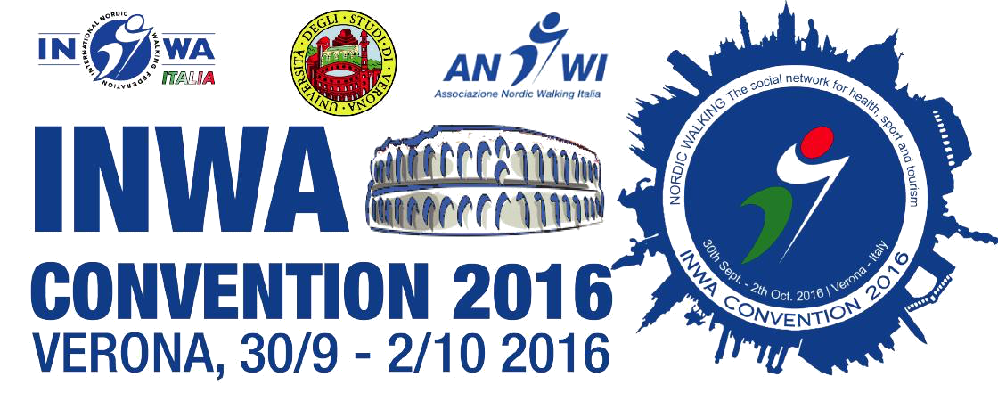
VERONA
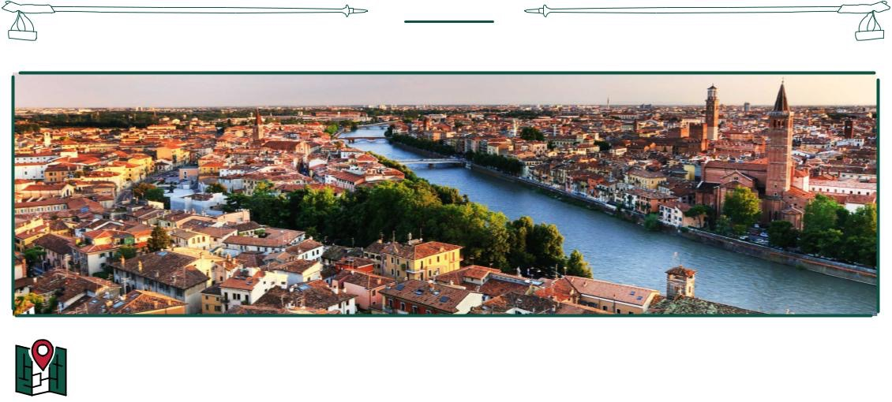

Verona is situated in the North – East of Italy. it is a UNESCO ‘s World Heritage Site for its urban architecture and it is important for its artistic monuments and archeological sites.
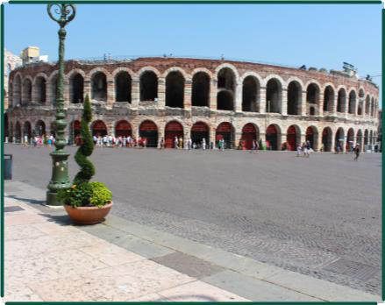
Shakespeare chose the city as a background for his well known tragedy, Romeo and Juliet. Verona has been built with marble, which is readily avaible in the caves north of the city. It is a common trait throught the different historical periods that are still clearly visible in the urban pattern of the city downtown and also one of the main reason why so many monuments are still very well preserved.
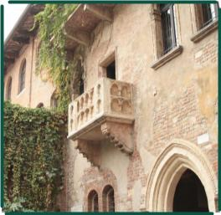

VERONA UNIVERSITY
SPORT SCIENCE

The convention INWA 2016, National Trainer Course, INWA AGM, will take place at the
Verona University – Sport Science:

Verona University, Sport Science Via Felice Casorati 37131 Verona, Italy
Palazzetto “Gavagnin” Via Montelungo, 7 – 37131 Verona Italy Related events will take place at the center of Verona or near university.
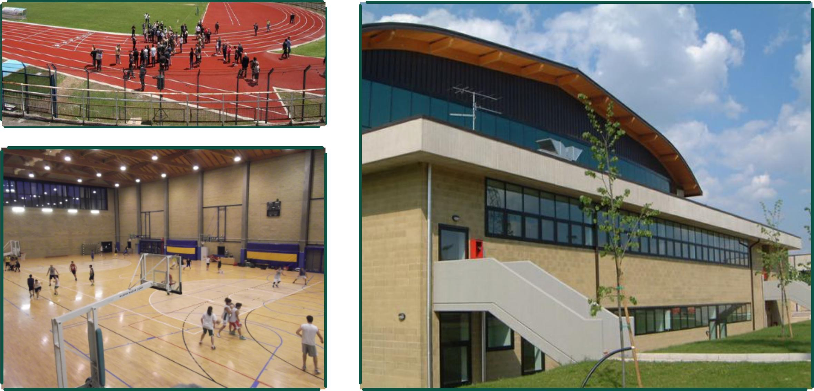
INWA
HOTELS

HOTEL MAXIM

Address: Via Carlo Belviglieri, 42, 37131 Verona VR
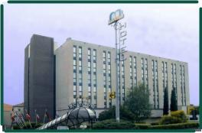
Phone: 045 8401800

www.maximverona.it

Double room for single use € 200,00

Doble room € 225,00

This price includes breakfast buffet

Minimum stay two nights : In 30/9 - Out 02/10/16

HOTEL BRANDOLI

Address: Via Antonio da Legnago, 11, 37141 Verona VR Phone: 045 8840155 - Fax: 045 8868100 www.hotelbrandoli.it info@hotelbrandoli.it
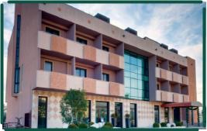
Double room for single use € 153,00 Doble room €170,00

The daily price for room include IVA at 10%, the service and the breakfast buffet

B&B Alla quinta Scala, Via de Zerbis, 13 | - | +39 3476942574 situated about 400 mt far from Scienze Motorie | Double room
B&B Al Giardinetto, Via Tiberghien, 11 | - | +39 3662157038 situated about 500 mt far from Scienze Motorie
 |  |  | around 100 €

B&B Corte Carolina Via Ponte Verde, 18 - +39 3484035163 situated about 200 mt far from Scienze Motorie

TRANSPORT
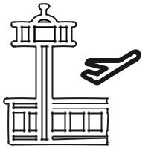

INTERNATIONAL AIRPORT

International Airport of Verona - Villafranca “ Valerio Catullo” 37066 Caselle di Sommacampagna (VR) www.aeroportoverona.it

International Airport of Venezia – Tessera “Marco Polo” Via Galileo Galilei, 30/1, 30173 Tessera, Venezia VE www.veniceairport.it

Internationl Airport of Bergamo – Orio al Serio “Il Caravaggio” Via Aeroporto, 13, 24050 Orio al Serio BG www.orioaeroporto.it

The nearest airport is in Verona- Villafranca "Valerio Catullo" : it’s distant about 12 Km from the city. The airport "Marco Polo" in Venice is distant almost 130 Km from Verona.

The airport in Bergamo "Orio al Serio" is distant almost 120 Km from Verona.
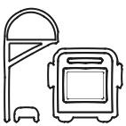

TRAIN STATION AND BUS

Train station of Verona – Porta Nuova Piazzale 25 Aprile, 37138 Verona VR

You can buy train tickets online, visit this website: www.veronaportanuova.it www.trenitalia.com There is an airbus service that connects the 'Verona Airport with the main Verona Station in 15 minutes. The shuttle operates every day and every 20 minutes until 00.48.

You can buy tickets online for the airbus service: http://www.aeroportoverona.it/aerobus_t2

You can easily reach the location of convention from train and bus station, you can buy tickets online for the bus: http://www.atv.verona.it/Atv_Verona_home_page

REGISTRATION
PROCEDURES

Registration Form: https://docs.google.com/forms/d/e/1FAIpQLSfeArVcuPxWGztlblcaPqSfOemZuL0wKipU4qLqOIHZQ7TSLg/viewform

Mode of Paymant: bank transfer only

The wire transfer must be headed to: ANWI ASS.SPORTIVA DIL. Banca: Monte dei Paschi Di Siena

Codice BIC: PASCITMMTRG

IBAN: IT 52 H 01030 38710 000000865612

In "Cause" box please write: First Name, Family Name, INWA VERONA 2016

Registration and Payment Deadline: September 19th 2016

Fee:
convention 3 days | € 300,00
convention 3 days and gala dinner | € 330,00
convention 2 days | € 260,00
convention 2 days and gala dinner | € 290,00
one day convention | € 150,00
one day convention and gala dinner | € 180,00
National trainer Corse | € 300,00
NW Regulariti’s Competition | € 15,00
For information: inwaverona2016@gmail.com

