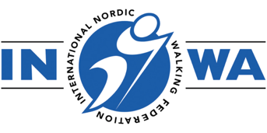
INWA NORDIC WALKING INSTRUCTOR COURSE

BOOKING FORM

Nordic Walking Instructors (NWI) are at the heart of INWA. Their role is to teach people how to Nordic Walk. NWI run groups for fitness, health, tourism or as a social activity.

Please complete this form to register for the above course:

Course Date: Sunday 7 and Monday 8 September 2025
Training Venue: Lahti, Finland

Your details:

NAME:
ORGANISATION (If relevant):
ADDRESS:
EMAIL:
MOBILE NO:

DO YOU SPEAK ENGLISH?

Do you hold a fitness, health, outdoor activity, or sports coaching qualification
(please list):

Please tell us a little about your previous Nordic Walking experience and background, and any prior experience you may have had that relates to the course:

Course Fees: €300
Includes:
All online materials including digital manual
2 day face to face practical course
Certification

If you are not a member of an INWA National Nordic Walking Association you will also need to pay an Affiliate Membership Fee of 150 Euro. Please contact the Office if you need further information on this.

Upon receipt of this booking form you will be sent an invoice, payment in full is required to secure your place.

To assist us in our marketing we would be grateful if you would answer the following two questions

Where did you first hear about this course?

Where did you hear about INWA?

CANCELLATION POLICY*:
30 days prior to the course commencement date: 50% charge
14 days prior to the course commencement date: 100% charge
*Please note that once education materials have been issued it is not possible to have a refund for cancellation, however you may be able to reschedule the course date in line with the above cancellation policy terms.

Signed: Date:

