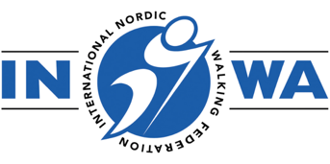
INWA CHILDREN & TEENS INSTRUCTOR

BOOKING FORM

The Children and Teens Course teaches Instructors how to adapt the INWA 10 Step Method to make it engaging and meaningful for children. The course focuses on developing physical literacy and supporting social and emotional learning, ensuring teaching is relevant, age-appropriate, and impactful.

Please complete this form to register for the above course:

Course Date: Sunday 7 and Monday 8 September 2025 with on-line seminar date to be confirmed.

Training Venue: Lahti, Finland

Your details:

NAME:
NNWA:
ADDRESS:
EMAIL:
MOBILE NO:
DATE OF NW INSTRUCTOR CERTIFICATION:

DO YOU SPEAK ENGLISH?

Do you currently work with children?

Please tell us a little about your plans to teach Nordic Walking to children and teens

Course Fees: €275
Includes:
All online materials including digital manual
2 hour on-line zoom seminar
8 hours of face to face practical sessions, split over 2 half days
Certification

Upon receipt of this booking form you will be sent an invoice, payment in full is required to secure your place.

If the invoice should be made out to someone other than yourself, please provide their details below:

To assist us in our marketing we would be grateful if you would answer the following question

Where did you first hear about this course?

CANCELLATION POLICY*:
30 days prior to the course commencement date: 50% charge
14 days prior to the course commencement date: 100% charge
*Please note that once education materials have been issued it is not possible to have a refund for cancellation, however you may be able to reschedule the course date in line with the above cancellation policy terms.

APPLICANT:

Signed: Date:

