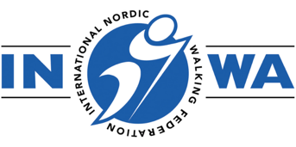
INWA RACE OFFICIAL NATIONAL REFEREE COURSE

BOOKING FORM

The INWA Race Official certification has two levels:
- A National Nordic Walking Referee is allowed to educate Race Officials in their own country and is required to be an INWA National Trainer.
- A Nordic Walking Referee is certified by INWA to judge NW technique during an INWA competition, and it is not required to be a certified Nordic Walking Instructor.

Please complete this form to register for the RACE OFFICAL NATIONAL REFEREE COURSE:

Course Date: Tuesday 9 September, 2- 5pm plus on-line seminar (date to be confirmed)

Training Venue: Lahti, Finland

Your details:

NAME:
NNWA:
ADDRESS:
EMAIL:
MOBILE NO:
DATE OF NT CERTIFICATION:

DO YOU SPEAK ENGLISH?

Course Fees: €245
Includes:
All online materials
3 hour on-line zoom seminar
3 hours of face to face practical sessions
Certification

Upon receipt of this booking form you will be sent an invoice, payment in full is required to secure your place.

If the invoice should be made out to someone other than yourself, please provide their details below:

To assist us in our marketing we would be grateful if you would answer the following question

Where did you first hear about this course?

CANCELLATION POLICY*:
30 days prior to the course commencement date: 50% charge
14 days prior to the course commencement date: 100% charge
*Please note that once education materials have been issued it is not possible to have a refund for cancellation, however you may be able to reschedule the course date in line with the above cancellation policy terms.

APPLICANT:

Signed: Date:

