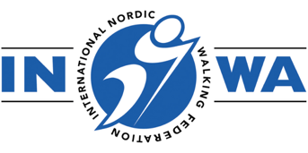
INWA NATIONAL TRAINER COURSE

BOOKING FORM

Our National Trainers (NT) work at a country level, training Instructors and Leaders for INWA Member Countries. As a teacher trainer, NT's play a key role in building a network of Instructors in their region.

Please complete this form to register for the above course:

Course Date: Sunday 7 and Monday 8 September 2025
Training Venue: Lahti, Finland

Your details:

NAME:
NNWA:
ADDRESS:
EMAIL:
MOBILE NO:
DATE OF NW INSTRUCTOR CERTIFICATION:

DO YOU SPEAK ENGLISH?

Do you hold a fitness, health, outdoor activity, or sports coaching qualification
(please list):

Please tell us a little about your Nordic Walking Teaching experience:

Course Fees: €400
Includes:
All online materials including digital manual
2 hour on-line zoom seminar
2 day face to face practical course
Certification

Upon receipt of this booking form you will be sent an invoice, payment in full is required to secure your place.

If the invoice should be made out to someone other than yourself, please provide their details below:

To assist us in our marketing we would be grateful if you would answer the following question

Where did you first hear about this course?

CANCELLATION POLICY*:
30 days prior to the course commencement date: 50% charge
14 days prior to the course commencement date: 100% charge
*Please note that once education materials have been issued it is not possible to have a refund for cancellation, however you may be able to reschedule the course date in line with the above cancellation policy terms.

APPLICANT:

Signed: Date:

NNWA REPRESENTATIVE:

Signed: Date:

Name:

