PRELIMINARY
PROGRAM
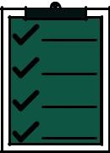

ACTIVITIES PRE-CONVENTION

INWA AGM
THURSDAY | 29 September | 9.00 |  | Registration
 |  | 10.00 |  | Start of INWA AGM
 |  | 13.00 | – 14.00 | Lunch
 |  | 14.00 |  | Continuation of work
 |  | 16.30 | – 17.00 | Coffee break
 |  | 17.00 | – 18.00 | Conclusion of AGM
 |  | 19.00 |  | Verona’s guided tour
 |  | 20.30 |  | Spritz aperitivo in the heart of city

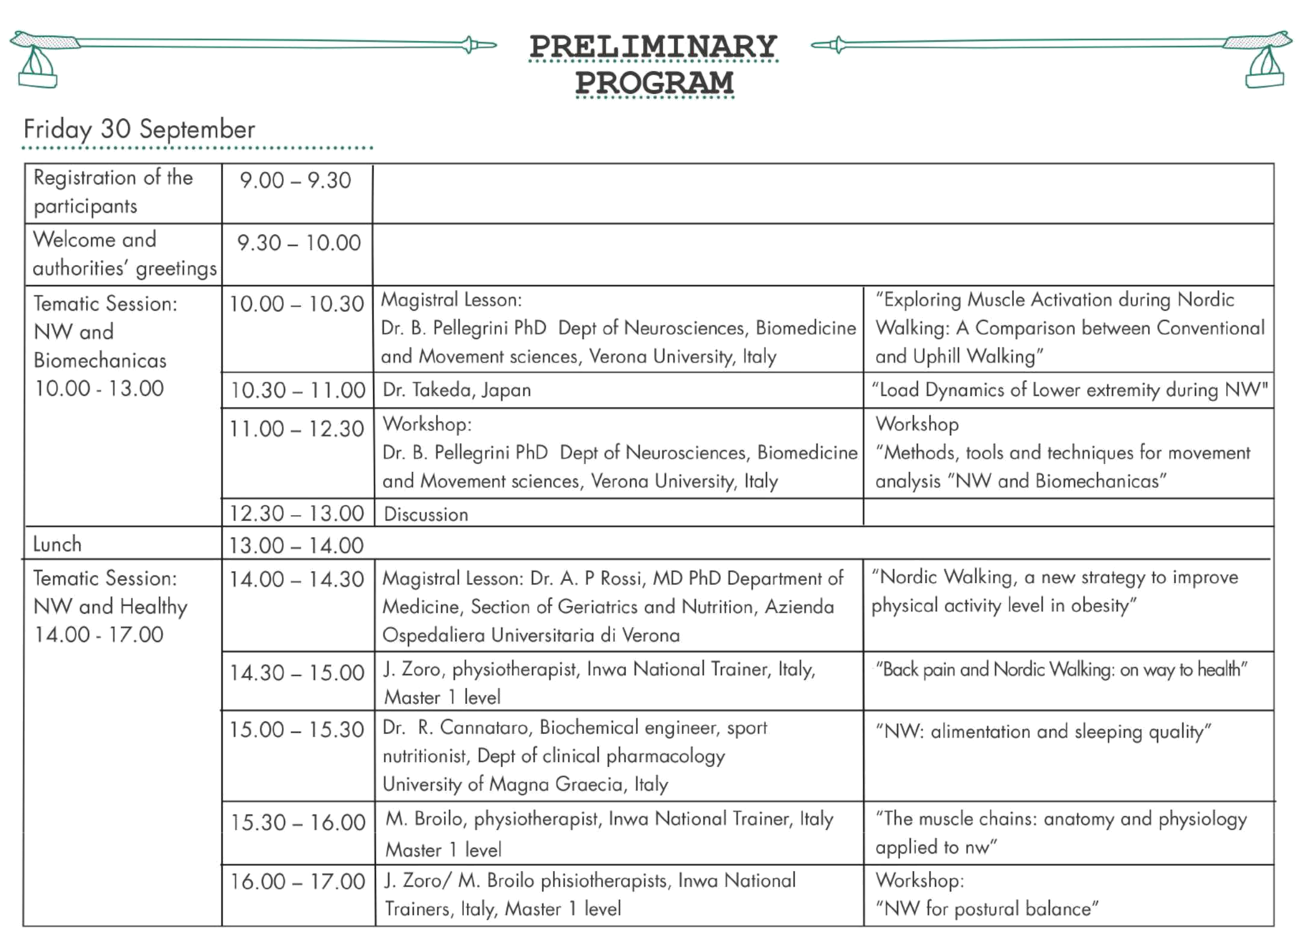
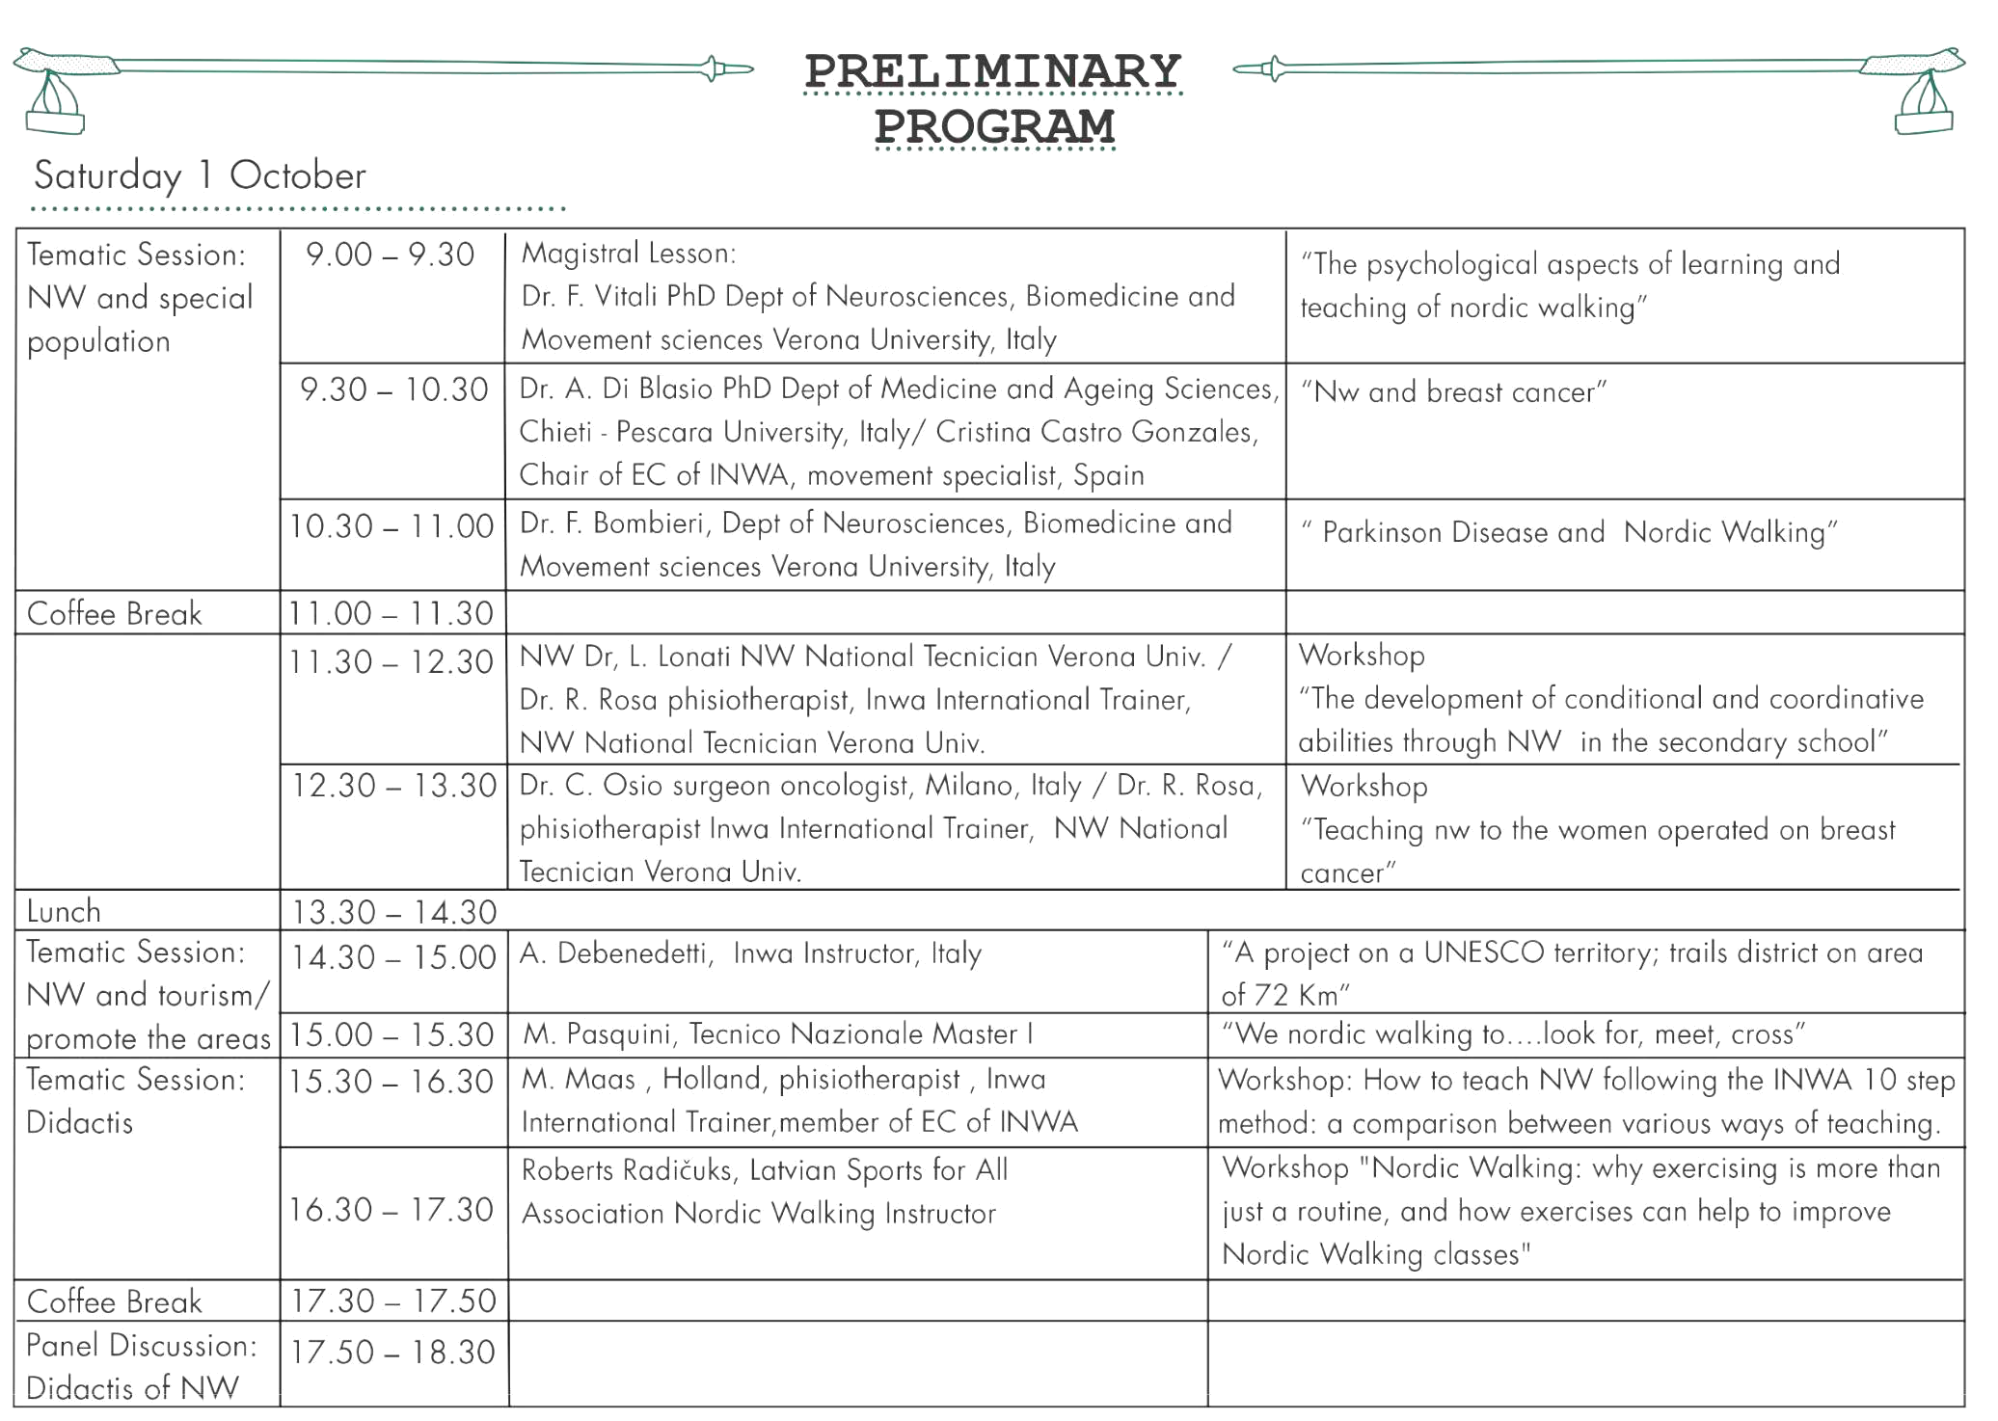
RELATED
EVENTS

THURSDAY 29 SEPTEMBER

19.00 | Verona’s Guided tour
20.30 | Spritz Aperitivo in the hearth of city

FRIDAY 30 SEPTEMBER

19.00 Verona’s Guided tour

SATURDAY 1 OCTOBER

20.30 Social dinner

SUNDAY 2 OCTOBER

10.00 | NW Regulariti’s Competition
10.00 | Didatic NW Trekking
13.00 | Awards cerimony, closing of work, greetings and light lunch

For information: inwaverona2016@gmail.com

