APPLICATION FORM TO JOIN INWA AS
A COUNTRY MEMBERSHIP

INTERNATIONAL NORDIC WALKING FEDERATION

REQUEST FOR ADMISSION TO THE INWA COUNTRY MEMBERSHIP

We (name of the ORGANISATION / COMPANY)

request to be admitted to the INWA Country Membership as:
an active Country Membership with voting rights at Annual INWA AGM.

We declare that the Organisation/ Company /Club
is not a member of any other NORDIC WALKING National Sport Federation (national or international) in conflict with INWA....................yes / no

Required information from the Applicant:

Contact details
NAME (FIRST) | SURNAME

Full Postal Address

Website address

E-mail address

Phone number

Fax number

Name of President or Other

E-mail of President or Other

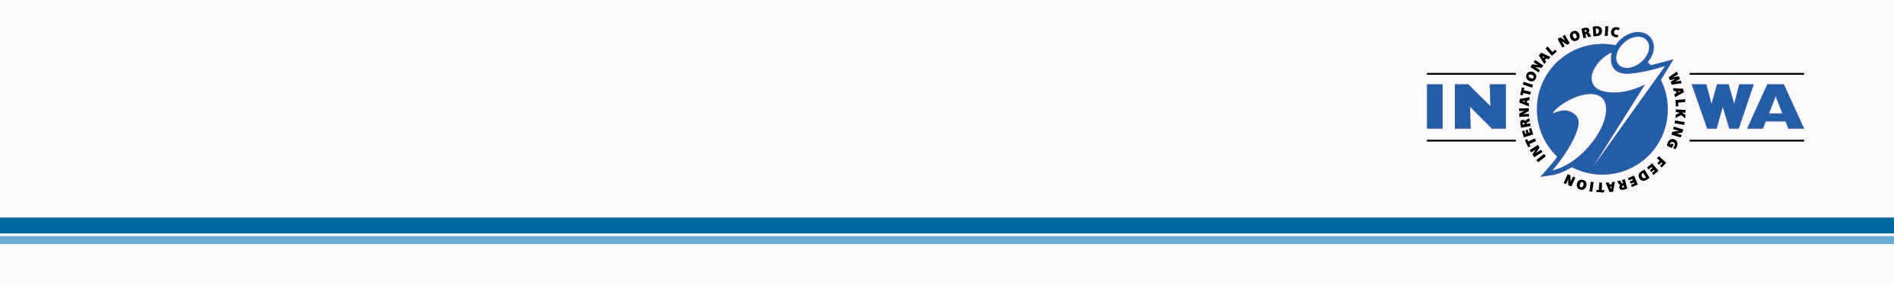

Name of General Secretary or Executive Director or Other

E-mail of General Secretary / Executive Director or Other

INTERNATIONAL NORDIC WALKING FEDERATION

Other Contact details (if applicable): Name and email

Training officer / leadership development

Information about the Organisation/ Company /Club
Year of foundation

Number of individual Nordic Walkers Guided by your Organisation / Company

Number of INWA Instructor trained under your Organisation / Company

Is the Organisation/ Company /Club recognised by any other National or
International organisation which you believe is relevant to Nordic Walking?
Yes/No
If yes, please name

Does the Organisation/ Company /Club have charitable status as a non-profit organisation? Yes / No

INTERNATIONAL NORDIC WALKING FEDERATION

What are the main reasons that your Organisation/ Company /Club wishes to join the INWA?

What does the Organisation/ Company /Club expect from the INWA?

INTERNATIONAL NORDIC WALKING FEDERATION

Documents to submit with this application
Please enclose the following documents with your application:
- Copy of all stated Nordic Walking Qualifications
- Most recent Annual Account and Balance Sheet
- Most recent Annual Report (if applicable)
- Statement from tax authorities confirming non-profit status (if applicable)
- Any other relevant information informing about your Organisation/ Company /Club (if applicable)

Declaration
On admission to the INWA, the Organisation/ Company /Club will pay the annual membership fee in accordance with Organisation/ Company /Club INWA RULES

The applicants have read the INWA RULES. The Organisation/ Company /Club agrees to abide by them and support the INWA in its mission to promote Nordic Walking worldwide.

This application must be sent to the INWA office by 1st of August for decision by the General Assembly in September of the same year.

Date: ........................................
Signature & Stamp .............................................................................................

Name and position in the Organisation/ Company
/Club....................................................................................

PLEASE RETURN TO INFO@INWA-NORDICWALKING.COM

